Patrons on BARD (or not)
Do you know which of your patrons don’t have a BARD account? You can combine queries to find potential new BARD subscribers or to track the effectiveness of BARD marketing pushes.
Or, if you just want to know how many active patrons are on BARD, skip the merge and run Query B on its own.

Query A: Potential Patron Base
Start with the query of patrons to check for a BARD account. This could be all Active patrons with an email address (recommended), or perhaps patrons that already use your WebOPAC.

Quick Search
Set your basic search criteria to narrow the field, such as:
- Active patrons Main Status | Equals | A
- At your own library Library ID | Equals | your library code, ex: KL1A
- Using Digital Books Pat Medium | Equals | DB
- Active in that medium Medium Status | Equals | A
- Only individual patrons Patron Type | Begins | P

Advanced Search
For patrons with an email address: Search for a complete range of possible email addresses. When querying against Contact records, you must specify both the Type and the Value.
- Contact | Type | Begins | E
- Contact | Value | Is Between | 1 | ZZZZZZ
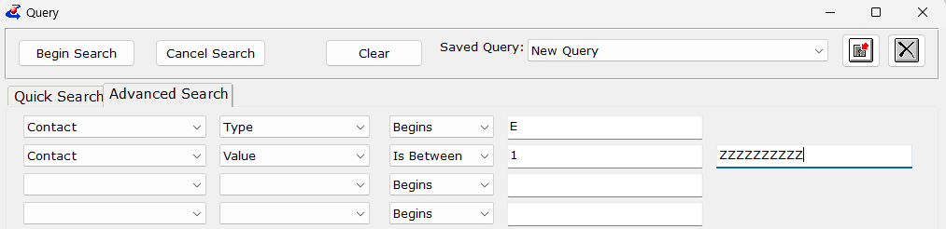
For patrons using your WebOPAC: Search against the Last Login date to find those who have logged in during that date range.
- WebOPAC | Last Login | Is between | one year ago | today’s date
Once you have your query results, make sure to open any result to open and save the Query Set.

Query B: Patrons on BARD
Next, query for all of the patrons that are BARD subscribers.
Quick Search
When querying against subscriptions, you should always narrow the field first to ensure the query can run in a reasonable amount of time. Re-use whichever Quick Search criteria you selected for Query A.
Advanced Search
All patrons with a BARD account should also have a Subscription to SER-DDB9. This records the existence of the account, is reported to PIMMS, and may be used for future integration.
- Subscription | KLAS ID | Equals | SER-DDB9
- Subscription | End Date | Is Blank
Once you have your query results, make sure to open any result to open and save the Query Set.

Merge Queries: In A Not B
Finally, open the Merge Queries tool from the Queries menu. For Query A, select the second-to-the-top query, with the criteria you selected for your potential patron base (such as Email address). For Query B, select the top listed query, with criteria including the subscription to DDB9.
Set the Merge type to “In A Not B.” All the patrons with an active BARD subscription will be removed from the list of potential BARD users, leaving you only with the potential users not yet subscribed to BARD. The total count is displayed, you can open any record to open/save the combined Query Set, and you can use the Export to Excel button to export only the combined results.
