How Robert Keeps His Author Headings (relatively) Clean

This is the method I’ve developed to try to keep my author headings under control. It’s designed to be used on a monthly basis, as soon as possible after the bibliographic record load, and it lets you look at the most recently added authors and compare them to any similar authors already in your headings. If it’s your first time using this method you may want to designate all authors added in the last two or three months as “new,” just to have a starting point to work from.

Go to View – Administration – Heading Maintenance
Select Header Type: Author
Sort by # Titles, lowest to highest. There will probably be a number of authors listed with zero titles. To make life easier later, get rid of these now. These are generally variants on existing author names and that’s what we’re trying to get rid of anyway. You can either delete the zero title authors one by one or you can do what I do:

Select as many zero title authors as there are on the first screen of results, except for one. (Use Ctrl-click or Shift-click to multi-select) You might want to make sure the one you don’t select has a fairly simple name. Don’t try to select across multiple screens as this sometimes causes problems.
You must be very careful to make sure none of your zero title authors have any likes or dislikes on them.
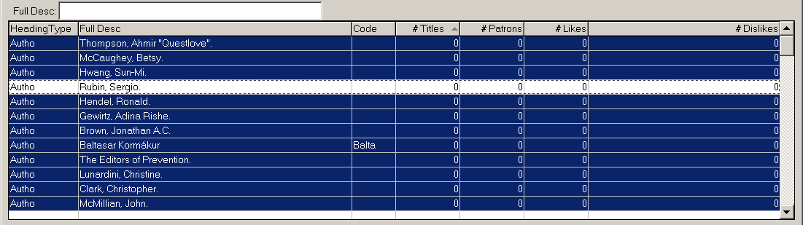
Click Merge Headings (or Alt-M)
Type the name of the one author you didn’t select in the FullDesc field. (This is why it’s nice to choose a short, simple name for this author.)
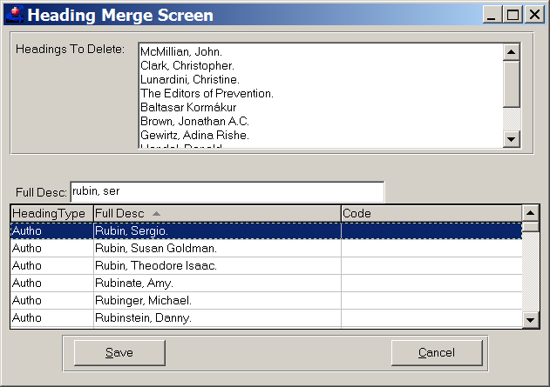
Click Save (or Alt-S)
Continue this process until you have only one zero title author left.
Delete that author.

Once you’ve gotten rid of the zero title authors:

Click Export (or Ctr-Alt-X)
Set Maximum to 50000 (to make sure you get all the authors) and click All Fields.
(this may take a while)
Find the ModifiedDate column and sort that column from Newest to Oldest
At this point it is very helpful to know the date of the last time the authors were checked. Select all the author’s names with a ModifiedDate after the last date you checked the authors. Select only the names in the Full Desc column, not the whole row for these authors.
Change the font color for these names. I usually pick red because that’s what Excel defaults to and it makes them easy to spot.
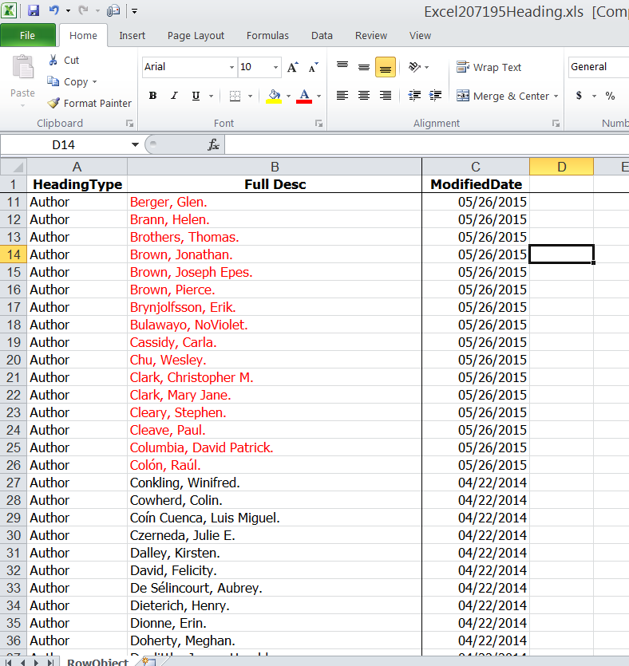
Select the Full Desc column and sort the names, A to Z. When it asks, expand the selection.
Click Find (Ctrl-F)
In the Find and Replace window, click Format
Click on the Font tab and select the same color that you changed the new authors to and click OK
Now begins the tedious-but-less-tedious-than-it-would-be-otherwise part of the program. Click Find Next. This will bring you to the first red author name, that is, the first new author name. If the name was already in Author headings with some kind of simple variation it should be right around it, probably right above or below it. If there’s no variant, Find Next again. If there is a variant, go back to Headings Maintenance and merge the variants into whichever form you want to keep.

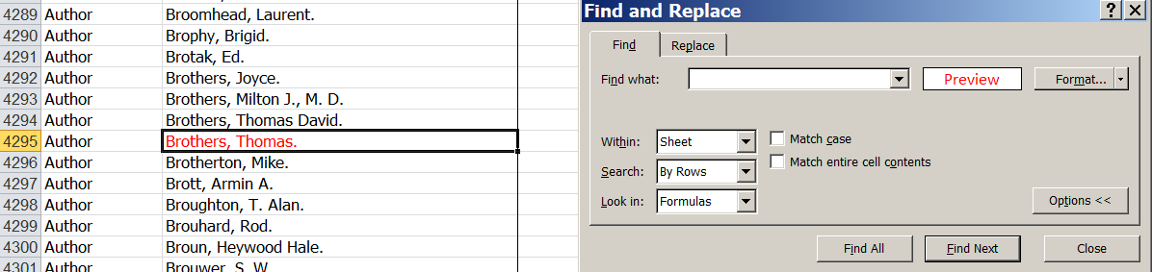
While skipping around and scrutinizing new authors you may well spot other, older author issues. Fix them, too!

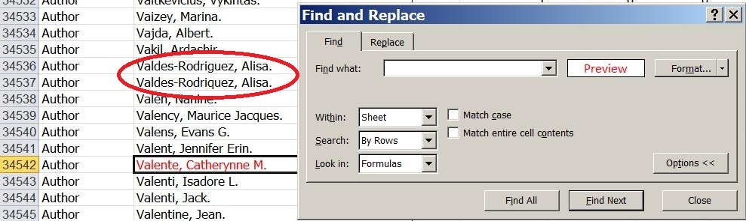

Continue this process until all the new authors have been checked. It’s a good idea to repeat this process with the Narrators as they can also have variants that need merging.

